**MATH2019 (Term 1, 2019) – Writing Assignment**

**Dan Nguyen (z5206032)**

**Question (1), Part (a):**

Question:

Given is a $3×3$ symmetric matrix *A*. The matrix *A* is:

$$A=\left(\begin{matrix}-97 & 18 & 30 \\ 18 & -166 & -48 \\ 30 & -48 & -80\end{matrix}\right)$$

*A* has three distinct eigenvalues; two of which are known:

$$λ_{1}=-98, λ_{2}=-49;$$

and an unknown eigenvalue *k*. This question requires the calculation of *k*.

Answer:

There exists a diagonal matrix *D* where its diagonal entries consists of the eigenvalues of *A*. The matrix *D* is:

$$D=\left(\begin{matrix}-98 & 0 & 0 \\ 0 & -49 & 0 \\ 0 & 0 & k\end{matrix}\right)$$

The trace (sum of main diagonal entries) of *A* is equal to the trace of *D*. Therefore *k* can then be calculated from the following:

$$trace(D)=trace(A)$$

$$-98-49+k=-97-166-80$$

$$∴k=-196$$

Therefore the value of the third eigenvalue *k*, for the matrix *A*, is -196.

**Question (1), Part (b):**

Question:

Following the question above, it is given that *A* also has three known linearly independent eigenvectors:

$${\vec{v}}_{1}=\left(\begin{matrix}6 \\ 3 \\ -2\end{matrix}\right) , {\vec{v}}_{2}=\left(\begin{matrix}3 \\ -2 \\ 6\end{matrix}\right) , {\vec{v}}_{3}=\left(\begin{matrix}2 \\ -6 \\ -3\end{matrix}\right)$$

with corresponding eigenvalues:

$$λ_{1}=-98, λ_{2}=-49, k=-196$$

This question requires the unknown orthogonal matrix *Q* for the diagonal matrix *D*, such that:

$D=Q^{T}AQ$.

Answer:

The set of eigenvectors of *A*, $\{{\vec{v}}_{1}, {\vec{v}}_{2}, {\vec{v}}_{3}\}$, are orthogonal because *A* is a symmetric matrix and has three distinct eigenvalues. But $\{{\vec{v}}_{1}, {\vec{v}}_{2}, {\vec{v}}_{3}\}$ is not orthonormal therefore an orthogonal matrix *Q* cannot be obtained since an orthogonal matrix is a square matrix that has columns and rows which are orthonormal vectors.

To determine the unit eigenvectors; the magnitude of each eigenvector is:

$$\left|\vec{v}\right|=\sqrt{6^{2}+3^{2}+{(-2)}^{2}}=7$$

A vector divided by its magnitude gives a unit vector which has a magnitude of one. Therefore the orthonormal set of eigenvectors are:

$${\vec{u}}_{1}=\frac{1}{7}\left(\begin{matrix}6 \\ 3 \\ -2\end{matrix}\right) , {\vec{u}}_{2}=\frac{1}{7}\left(\begin{matrix}3 \\ -2 \\ 6\end{matrix}\right) , {\vec{u}}_{3}=\frac{1}{7}\left(\begin{matrix}2 \\ -6 \\ -3\end{matrix}\right)$$

The orthonormal set of eigenvectors of *A* with respect to its corresponding eigenvalues in *D* make up the columns of the orthogonal matrix *Q*:

$$Q=\left(\begin{matrix}\frac{6}{7} & \frac{3}{7} & \frac{2}{7} \\ \frac{3}{7} & -\frac{2}{7} & -\frac{6}{7} \\ -\frac{2}{7} & \frac{6}{7} & -\frac{3}{7}\end{matrix}\right)$$

$$∴Q=\frac{1}{7}\left(\begin{matrix}6 & 3 & 2 \\ 3 & -2 & -6 \\ -2 & 6 & -3\end{matrix}\right)$$

**Question (2):**

Question:

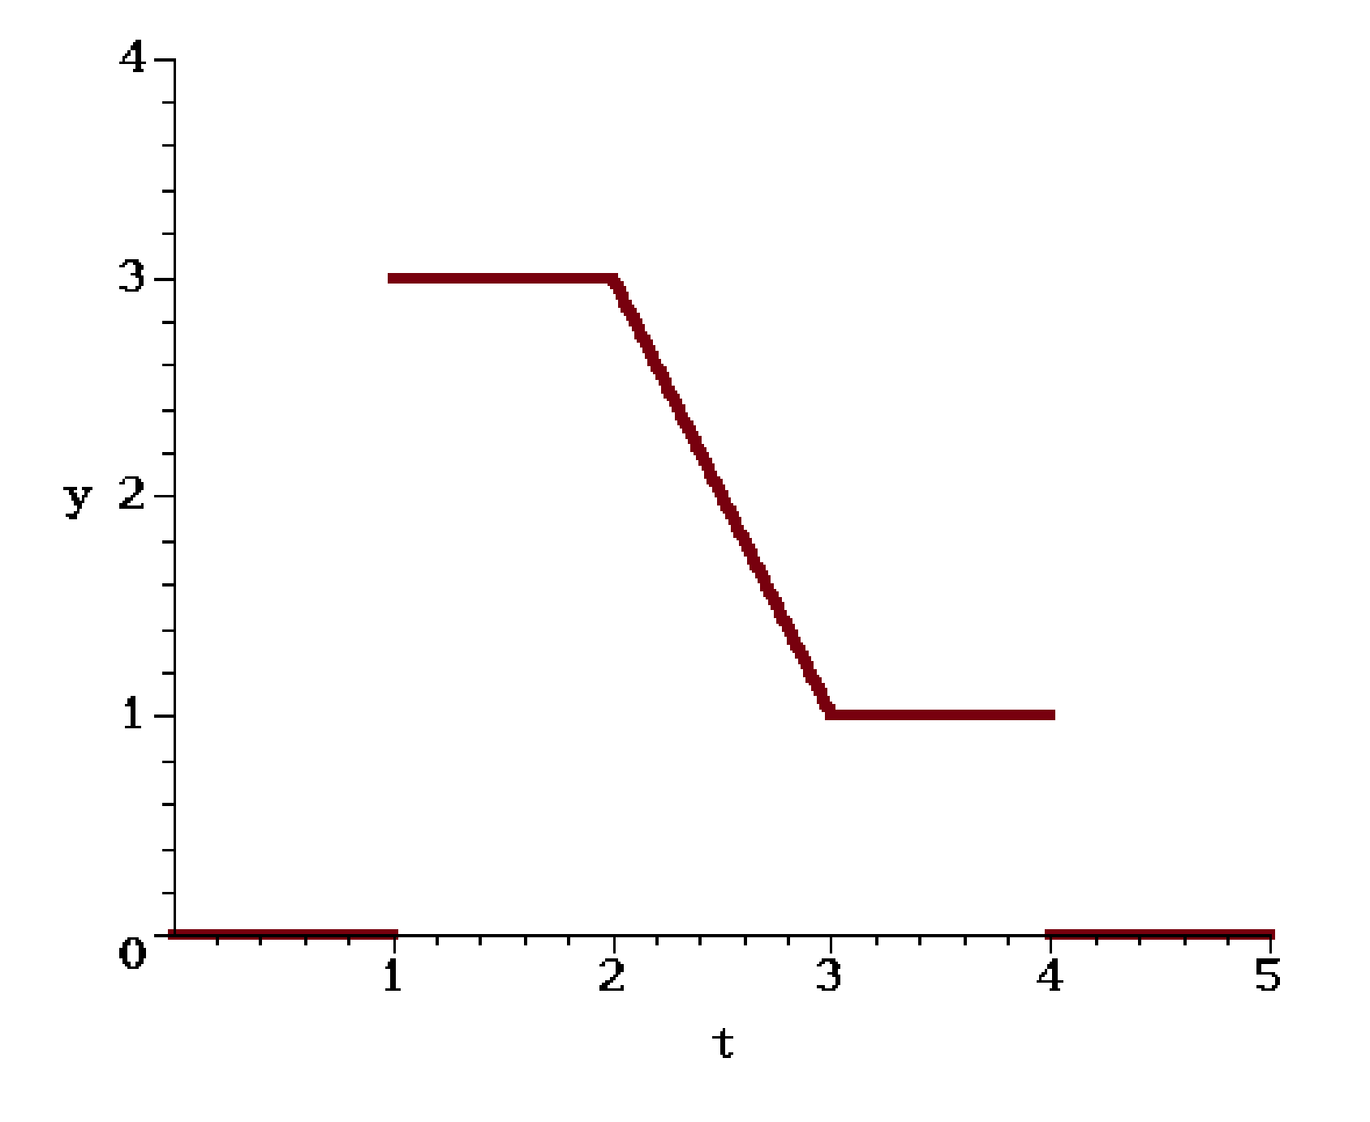

**Figure 1 – graph of y(t)**

This question requires the function $y(t)$ of the above graph (figure 1) to be expressed using Heaviside function notation.

The Heaviside function is:

$$u\left(t-c\right)=\left\{\begin{aligned}1, &t≥c \\ 0, &t<c\end{aligned}\right.$$

where *c* is a real constant.

Answer:

By considering each piece of the graph in figure 1 to get an equation for a particular domain:

For $0≤t<1:$ $y=0$

For $1≤t<2$: $y=3$

For $2≤t<3:$

The line is calculated using the two-point formula:

$$\frac{y-y_{1}}{t-t_{1}}=\frac{y_{2}-y_{1}}{t_{2}-t_{1}}$$

and picking two points lying on the line:

$$\left(2, 3\right), (3, 1)$$

So,

$$\frac{y-3}{t-2}=\frac{1-3}{3-2}$$

$$∴y=-2t+7$$

For $3≤t<4$: $y=1$

For $4≤t≤5$: $y=0$

$y(t)$ can now be expressed as a piece-wise function:

$$y\left(t\right)=\left\{\begin{matrix}0 & 0≤t<1 \\ 3 & 1≤t<2 \\ -2t+7 & 2≤t<3 \\ 1 & 3≤t<4 \\ 0 & 4≤t≤5\end{matrix}\right.$$

Consider the piece-wise function and when each piece of $y(t)$“starts” and “stops”. For example:

The Heaviside expression for an interval $[a,b]$ with unit value is:

$$u\left(t-a\right)-u(t-b)=\left\{\begin{aligned}1, &a≤t≤b \\ 0, &t<a∪t>b\end{aligned}\right.$$

where *a* and *b* are real constants.

The interval $[1,2)$ has an equivalent Heaviside expression of:

$$u\left(t-1\right)-u(t-2)$$

Over this interval, the function is:

$$y=3$$

Therefore the Heaviside expression for $1≤t<2$ is:

$$3\left(u\left(t-1\right)-u\left(t-2\right)\right)$$

That is, the function is $y=3$ which starts at $t=1$ and stops at $t=2$.

Expressing $y(t)$ as a Heaviside expression:

$$y\left(t\right)= 0\left(u\left(t-0\right)-u\left(t-1\right)\right) \\ +3\left(u\left(t-1\right)-u\left(t-2\right)\right) \\ +\left(-2t+7\right)\left(u\left(t-2\right)-u\left(t-3\right)\right) \\ +1\left(u\left(t-3\right)-u\left(t-4\right)\right) \\ +0\left(u\left(t-4\right)-u(t-5)\right)$$

$$∴y\left(t\right)=3u\left(t-1\right)+\left(-2t+4\right)u\left(t-2\right)+\left(2t-6\right)u\left(t-3\right)-u(t-4)$$

is the Heaviside expression of the graph of figure 1.